2018 Spring Meeting – Thursday, May 10, 2018
Reception 5:30 PM
Dinner & Presentation 6:30 PM

Retirement Readiness

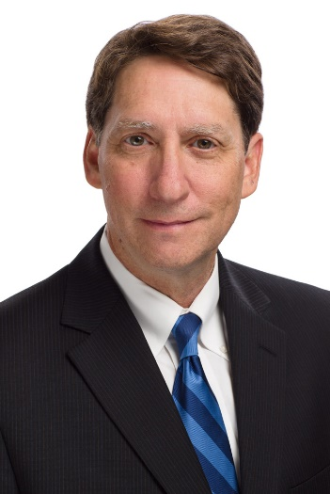

Our speaker for the evening will be Ted Goldman, the Senior Pension Fellow at the American Academy of Actuaries. In this role, Mr. Goldman helps shape and communicate the Academy’s work on pensions, Social Security, and other retirement security issues to the public, policymakers, and the news media. Mr. Goldman was previously a retirement consultant with several major human resources consulting firms. Mr. Goldman is a member of the American Academy of Actuaries and a fellow of the Society of Actuaries, an Enrolled Actuary, and a fellow of the Conference of Consulting Actuaries and holds a Bachelor of Arts in Mathematics from the University of Missouri, Columbia.

Mr. Goldman will present on retirement readiness. A recent survey, conducted jointly by the American Academy of Actuaries, the Actuaries Institute of Australia, and the Institute and Faculty of Actuaries (U.K.), uncovered some interesting findings about how residents in the U. S., U.K., and Australia are (or are not) preparing for their retirement. This presentation will share the main findings of the survey, including: how the changing social, demographic, and economic landscape has transformed retirement expectations; the strategies and level of success of accumulating wealth to prepare for retirement; and the ability of individuals to consider and plan for the unexpected events that may occur during retirement.

The 2018 Spring Meeting will be held at the Sheraton Columbia Town Center:
Sheraton Columbia Town Center
10207 Wincopin Circle, Columbia, MD 21044
410-730-3900
http://www.sheratoncolumbia.com.

Please complete and return this form by Thursday, May 3:

I will attend the Spring Meeting on May 10, 2018.

Name:

Email address:

Current employer:

Payment:

Registration ($60 per person) $

Mail this registration form along with payment (made payable to the Middle Atlantic

Actuarial Club) to:

Kyle Burkhalter
c/o Office of the Chief Actuary
Social Security Administration
6401 Security Blvd, Baltimore MD 21235

For special arrangements, such as employer payments, special dietary considerations, or any other concerns please contact:

Kyle Burkhalter at kyle.e.burkhalter@ssa.gov or at 410-966-1335.

Kosher meals will be provided upon request.

