2019 Spring Meeting – Wednesday, May 15, 2019
Reception 5:30 PM
Dinner & Presentation 6:30 PM

The Actuarial Board for Counseling and Discipline. Ethics and Professionalism: An Overview

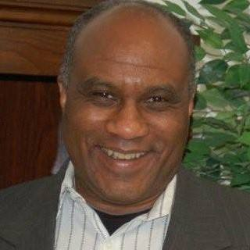

Our speaker for the evening will be Brian Jackson, J.D. Mr. Jackson has been a staff attorney at the American Academy of Actuaries since January 2012. He advises, and coordinates the work of, the Actuarial Board for Counseling and Discipline ("ABCD"), which was established through the Academy’s bylaws, but serves the profession as a whole. Prior to joining the Academy staff, Brian served 22 years in the United States Marine Corps as a Marine lawyer. During approximately 16 of those years, he either prosecuted or defended criminal cases. Three of those years were spent serving as the lead defense counsel for one of the High Profile Detainees currently held in Guantanamo Bay, Cuba. Brian received his Bachelor’s degree in Political Science from University of Maryland, College Park, and his Law degree from the Washington & Lee School of Law in Lexington, Va. He is a member of the American Bar Association, the New Jersey Bar, and District of Columbia Bar.

Mr. Jackson will present an overview of the ABCD and its processes; review and discuss the Code of Professional Conduct; and engage the attendees in a case study.

The 2019 Spring Meeting will be held at the Sheraton Columbia Town Center:
Sheraton Columbia Town Center
10207 Wincopin Circle, Columbia, MD 21044
410-730-3900
http://www.sheratoncolumbia.com.

Please complete and return this form by Wednesday, May 8:

I will attend the Spring Meeting on May 15, 2019.

Name:

Email address:

Current employer:

Payment:

Registration ($60 per person) $

Mail this registration form along with payment (check made payable to the Middle Atlantic Actuarial Club or PayPal to email address kyle.e.burkhalter@ssa.gov) to:

Chelsea Shudtz
c/o Office of the Chief Actuary
Social Security Administration
6401 Security Blvd, Baltimore MD 21235

For special arrangements, such as employer payments, special dietary considerations, or any other concerns please contact:

Chelsea Shudtz at chelsea.a.shudtz@ssa.gov or at 410-966-0545.

Kosher meals will be provided upon request.

